Review Sheet for Bio 230, Exam 3, 2016

- What is the general function of transcription factors in cells, and how do they accomplish this function?

- Describe one example of negative control of gene expression.

- In a repressible operon such as the regulation of tryptophan metabolism, how would you cause the repressor to inactivate?

- Every cell with a nucleus within a multicellular organism contains the same DNA within its nucleus. Describe how the major differences between cell types originate, meaning, how does the same genome lead to many different cell types?

- Describe a technique that you would use to measure the mRNA that is expressed in a cell.

- Name one modification of histones and describe the histone code.

- What is DNA wrapped around histones called and what is its function?
  - It is called a nucleolus and it helps to initiate translation.
  - It is called a nucleolus and it helps to compact DNA.
  - It is called a nucleosome and it helps to initiate translation.
  - It is called a nucleosome and it helps to compact DNA.

- Which amino acids are coded for by the codons 5’ CAC AAG GGG 3’, and how would they be affected by changes in the third positions of the codons?

- How will translation be affected if a cell is unable to synthesize or obtain methionine?

- After the initiation of translation, which site in the ribosome do charged tRNAs enter and bind?

- Name a post-transcriptional modification and state what role that it serves.

- Why are immature mRNAs much longer than mature mRNAs?

- Where does RNA polymerase bind to initiate transcription in prokaryotes or eukaryotes?

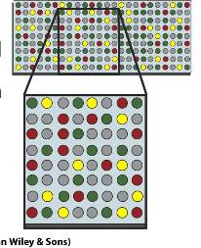
- In this picture of a DNA microarray (gene chip), why are some spots colored red, yellow or green, and others are colored gray?

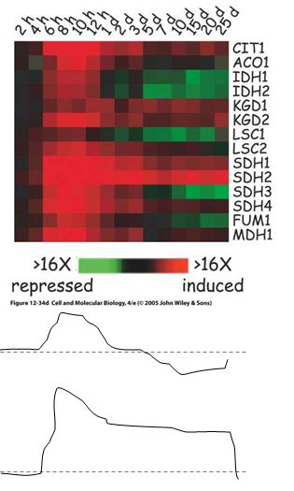
- The diagram to the right displays the time course of mRNA expression for genes in involved in the TCA cycle. Below that are two solid lines, with the dashed lines representing baseline gene expression, and upwards from that line is considered higher gene expression, with time along the x-axis the same as the top graph. Reading the graph to the right, which genes could give the gene expression profiles shown for the top solid line or the bottom solid line? You may use the 4 letter gene name for your answer (e.g. CIT1) Only one answer is sufficient for each, even if there is more than one potential answer.

- What is the open reading frame and why is it important for gene and protein sequencing?

- What will be the consequence of inserting a uracil into the 6th position in the following sequence. Assume that you begin in the open reading frame.
5’-GAG-CCC-AAA-CGC-3’

- What is a consensus sequence?

- What serves as the intermediate between mRNA and protein?

- If the 3’ end of the tRNA has been cleaved, what part of translation will be affected?

- How many amino acids does each codon code for? Is the number of codons for each amino acid, larger, smaller or the same?

- What are the main steps in translation by the ribosome?

- A space probe brings back a new life form. It is carbon-based and its genetic material is similar to Earth DNA except that it uses 6 different nucleotide bases instead of 4. Its proteins are also similar to those on Earth, but there are 28 amino acids instead of 20. You hypothesize about the genetic code for this organism. How many "letters" would you propose in each codon of the genetic code for this organism? The code should be unambiguous and may be degenerate.

- Which steps in translation require ATP hydrolysis? Which steps require GTP hydrolysis?

- Construct a genetic AND, OR, and NAND logic circuit.

- In the inducible operon, what would be an example of positive control? Of negative control? Which components would constitute an AND circuit?

- In the repressible operon, what would be an example of negative control? Which components would constitute a NAND circuit?

- Describe how a DNA microarray works.

- Which histone modifications permit or repress transcription and where on the histone are the modifications made?

- What types of DNA represented by the highly repeated, moderately repeated and non-repeated fractions of eukaryotic DNA?

- If the β-clamp of the replisome is damaged, will the leading strand or lagging strand, both or neither be affected and why?

- What process would be affected by alteration of the sigma factor?

- Draw and label the key components of replication on the leading and lagging strands.

- Which components are found in both DNA replication and DNA repair?

- During replication, which strand would contain more RNA and why?

